# Phase 4: Process Automation (Admin)

This document outlines the core declarative automation implemented for the "Simple Event Management & Attendee Tracking System." This automation enforces data quality and automates key processes to improve efficiency.

### Validation Rule: Max Capacity Check

1. **Purpose:** To prevent the creation of an Event with an invalid capacity, ensuring data accuracy and is a prerequisite for the overbooking check in Phase 5.
2. **Rule Name:** Max_Capacity_Must_Be_Positive
3. **Error Condition Formula:** Max_Capacity__c < 1

**Error Message:** "Maximum Capacity must be a number greater than 0."

1. **Error Location:** The Max Capacity field.

**Impact:** Ensures every event has a valid capacity, preventing errors in downstream automation.

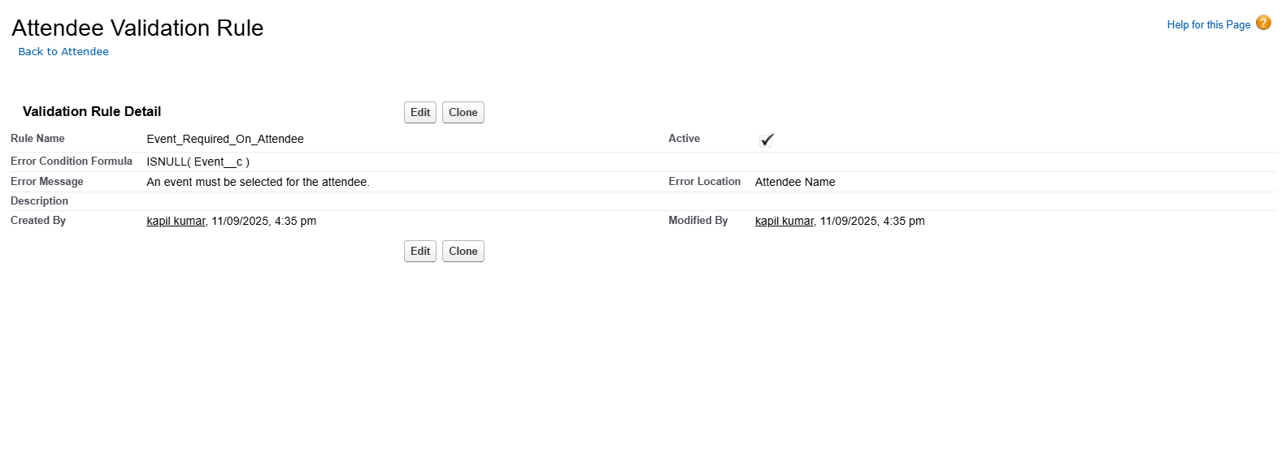

### Flow Builder: Attendee Confirmation

1. **Purpose:** To automate the communication process by sending an instant confirmation email to a new attendee upon registration.
2. **Type:** Record-Triggered Flow.
3. **Object:** Attendee.
4. **Trigger:** A record is **Created**.
5. **Action:** **Send Email** action.
6. **Email Template:** Attendee Confirmation (Lightning Email Template).

**Impact:** This flow provides instant feedback to the registrant and eliminates the need for manual confirmation, saving time for the event manager.

